Project Update 2

Team #: B7
Team Members: Damian Grochowski, Ryan Whitehouse, Ole Nagorsen, Michael Lee, Reid Brock

Our Story to this point:
Since our last project update, some of the things that we wanted to look deeper at were some potential external impacts on our data, as well as finding reasoning for some of our data. We wanted to start off this update by briefly addressing the insurance cost numbers in our dataset. The numbers seemed high to us, but actually make sense within the context of the data. First, the data is of medical insurance cost billed to beneficiaries, not just the annual premium. “Insurance costs billed to beneficiaries” may include premiums, deductibles, copayments, and coinsurance. This may explain some of the outliers (some individuals paid over $50,000). Additionally, in the United States, the average annual premium for employer-sponsored health insurance in 2024 was $8,951 for single coverage. Higher insurance costs for smokers may originate from the high costs of treating its added health conditions. Nationwide, cigarette smoking adds around $100 billion in annual incremental direct healthcare costs, which could partially explain the different “tier” of insurance costs we observe for the individuals in the dataset that are smokers. Our data shows the existence of a pretty clear three tiers, something that we did outside research on below. We want to use these three distinct tiers to predict insurance costs for individuals based on their physical conditions and behavior (smoking vs. non-smoking). This will allow patients to predict which “risk segment” they are likely placed into by their insurance provider.

Models:
In order to predict insurance medical costs, we have to use a regression model. First, we tried predicting the cost with a classic linear regression. The results were fine with an r^2 accuracy score of 74.76% and RMSE of 6050.2185, we needed something better. Next, we created a regression tree, for a potential increase in accuracy and better interpretability of the data. The decision confirmed our theory of smoking largely affecting cost, and age and BMI playing a part as well. Out tuned regression tree showed an r^2 of 86.4% and RMSE of 4365.1889. To increase our accuracy we ran a random forest regressor and ran a grid search to achieve a final r^2 score of 89.8%, which is really good for a regression model.
After trying different forms of models we realized that each individual profile seemed to have their own slope and characteristics so we tried to categorize users into three main profiles: low, medium and high cost profiles. After examining trends within the data in Figure 1 and outside research we decided to delineate every 15,000$, 0-15,000, 15,000-30,000 and 30,000+. In figure 2 you can see a general profile of our data set with cut offs and smoking profile 1= true. To solve this problem in our final model we have been experimenting with two different forms of classification: a Random Forest Model and Logistic Regression model. These models exclude the user's premium as a variable because our model is hoping to predict the individual prescriber's price. The issue we had with both our Random Forest and Logistic Regression was a blurring of the middle price class and reduced accuracy of identification which can be seen in Figures 3 and 4.

Expanded Outside Research:
Outside research supports our decision to divide individuals into three distinct cost profiles. Our first project report discusses the concept of risk pooling insurance companies utilize to group homogenous members. Further research conducted concludes that insurance companies function more effectively when insurers are better able to classify individuals into distinct risk categories. Individuals with similar levels of risks are pooled together, ensuring members of each group pay similar insurance premiums and costs, decreasing the negative implications of adverse selection. Insurance companies are more efficient if they are able to correctly categorize and charge the correct price. Essentially, they work best when there is a balanced mix of different levels of “risk” individuals. This form of risk classification actually mirrors real industry practices. A report conducted by Marsh & McLennan/Oliver Wyman concluded that most insurers classify smoking risks into mainly two or three different groups: non-smokers, smokers, and heavy-smokers, with smokers being charged up to four times higher premiums than non-smokers. These sources align perfectly with our model: individuals are segmented into three distinct cost profiles/buckets, depending on their smoking habits and related health risks. As an individual(s) smoking habits increase, they are sorted into higher cost groups, reflecting their high risk factors. Individuals with moderate smoking levels and non-smokers are accurately profiled into lower cost buckets. All this ensures proper stability and balance between each distinct cost profile, where the costs for each profile accurately reflect the habits and health risks and factors of its members. Finally, a noteworthy source (_____)

Next Steps:
Our next steps include refining our classification model and creating a dependent regression model that we test against our current random forest regression model. Our current classification models currently struggle with identifying the middle class so more tuning is needed. Once we complete the classification model we would like to try and create a regression model based upon values within each individual bucket in hopes it can out perform our current random forest regression model. We also would like to finish our indepth research into the insurance price market to see if there are any deeper insights within.

References / Index

Figure 1: Distribution of Insurance Prices
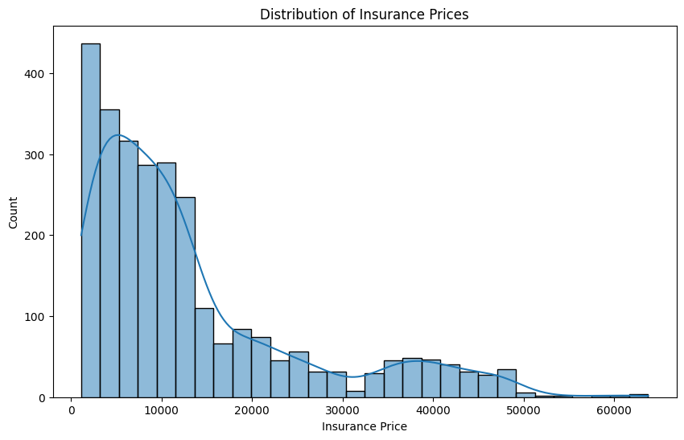
Figure 2: Insurance Price and Age broken down by Bucket
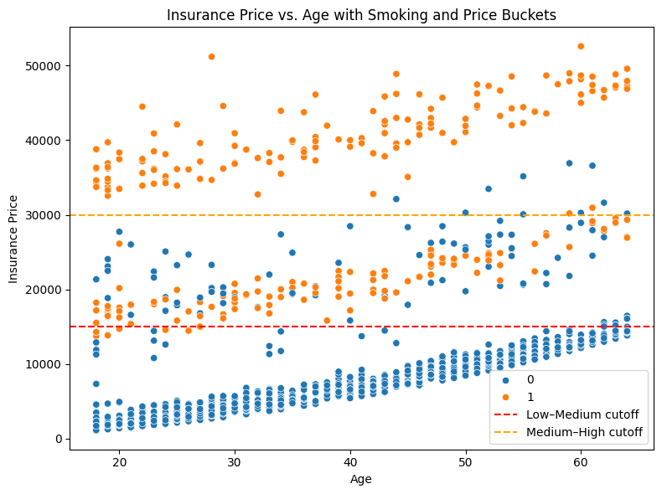
Figure 3: Logistical Regression Results
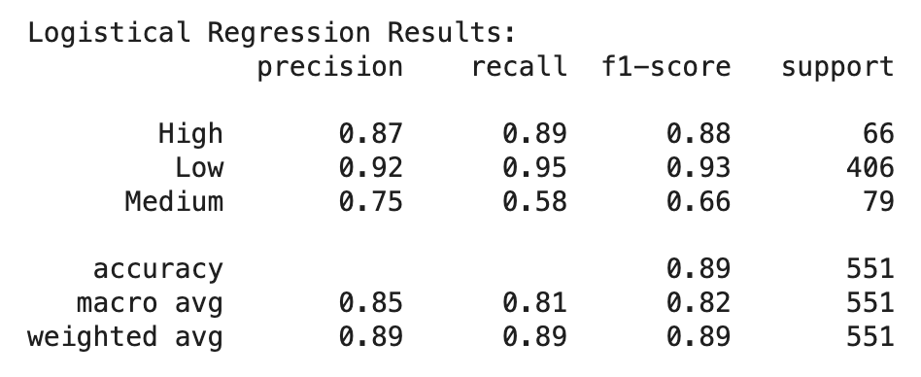
Figure 4: Random Forest Results
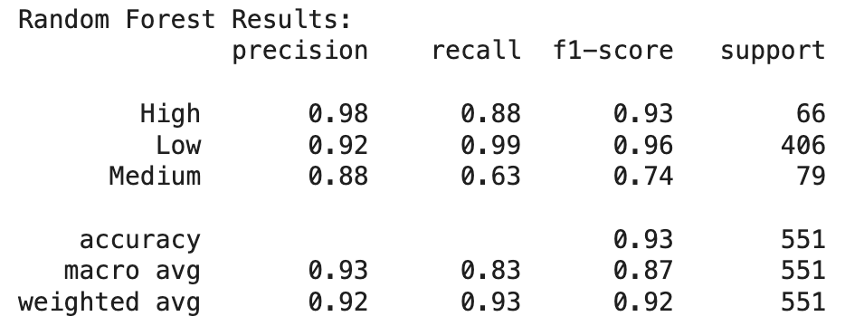

Regression Tree (RMSE= 4857.793 R2= 0.831)

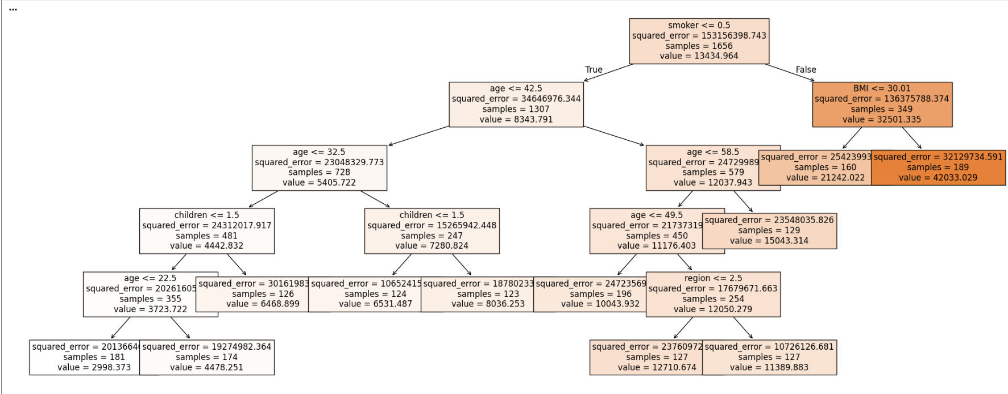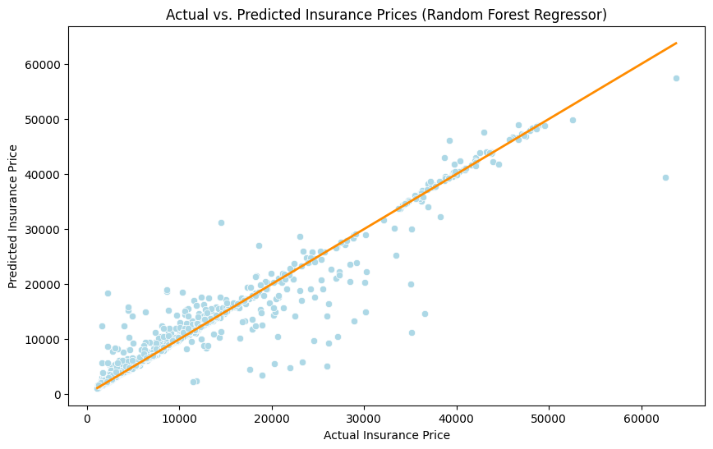

Actual vs. Predicted Insurance Prices (Regression Tree)

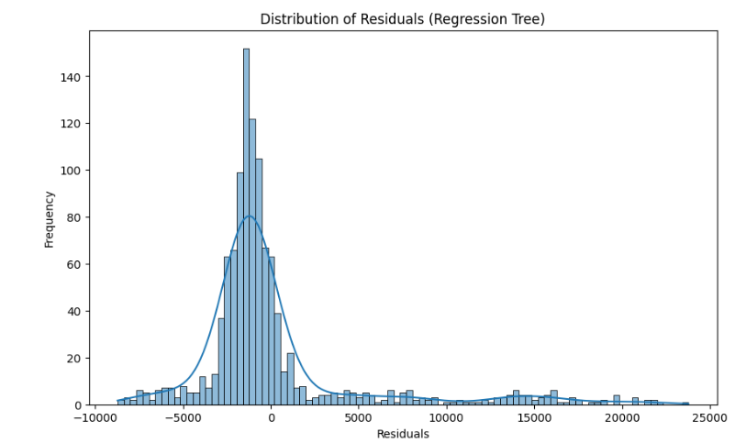

Porrini, Donatella. 2015. "Risk Classification Efficiency and the Insurance Market Regulation" Risks 3, no. 4: 445-454. https://doi.org/10.3390/risks3040445
Kaiser Family Foundation. 2024. 2024 Employer Health Benefits Survey. Kaiser Family Foundation. https://www.kff.org/health-costs/2024-employer-health-benefits-survey/#3f3fc2dd-74dd-4cb6-9d1c-9c19ff972f6a
Warner, David O., Benjamin J. Borah, John Moriarty, David R. Schroeder, Yan Shi, and Nilay D. Shah. "Smoking Status and Health Care Costs in the Perioperative Period: A Population-Based Study." JAMA Surgery 149, no. 3 (March 2014): 259–266. https://doi.org/10.1001/jamasurg.2013.5009
Insurer Perspectives on Smoking Risks, accessed November 6, 2025, https://www.marshmclennan.com/assets/insights/publications/2019/oct/20191030_Insure_Perspectives_on_Smoking_Risks.pdf.
Ibid.

